**Assignment 3**

**1. PCIDSS, HIPPA and other compliances ppt or blog**

Introduction to Compliance Frameworks

Compliance standards are very important in today’s world and include PCI DSS and HIPAA among others. These compliance frameworks provide assurance that an organization handling sensitive data does it in the most appropriate manner. PCI DSS was created to minimize the risk of loss of cardholder data throughout payment transactions while HIPAA protects PHI within the healthcare context. Such frameworks also help in reducing risks, preventing data leaks, and establishing ways and trust relations between business and customers or patients.

Understanding PCI DSS

Major credit card brands designed the Payment Card Industry Data Security Standard (PCI DSS) explicitly to protect cardholder data through the processes of capture, storage, and interchange. It encompasses all organizations that accept or process payment transactions – from merchants through to service providers. Among other things, firewall deployment, encryption of card holders' information, need-based information access, and periodical vulnerability appraisal form part of the requirements. Organizations may be classified into four groups depending on the volume of transactions processed annually. Failure to comply is not automatically met with penalties in the form of legal citations but may bring negative publicity and lawsuits after data leaks have occurred to the concerned institutions.

Understanding HIPAA

HIPAA is helpful in protecting PHI as stated into the Health Insurance Portability and Accountability Act which is – among others –single source of complaint administrative focused and its main goal is privacy. As per HIPAA requirements, Insurers and their business associates are to undertake risk management steps, undertaking assessments, using encryption and placing access controls and measures for breach notification. In contrast to PCI DSS, HIPAA lacks a formal certification process but is enforced through OCR also known as the Office for Civil Rights who conduct audits. Offenders are likely to face points of severe fines and legal sanctions. This framework is important in ensuring that patient confidence is maintained and sensitive health information is protected.

Influence of Other Compliance Frameworks

In addition to PCI DSS and HIPAA, there are other frameworks that aim for the protection of data as well: GDPR (General Data Protection Regulation): Encompasses all EU citizen data everywhere, focusing on data subjects’ rights, allowing for greater transparency and tougher sanctions on the infringer. CCPA (California Consumer Privacy Act): Offers California citizens the right to their data by forcing businesses to have consent to seek that information and allowing a consumer opts-out for any data selling options. Both regulations focus on encryption, access control and the barriers to user transparency thus forming a strong basis for privacy standards all over the world.

Differences between HIPAA and PCI DSS Compliance Standards

Common between the two, but, PCI DSS focus on technical and administrative processes of compliance and data security as a priority, HIPAA is broader.

Similarities: Need for encryption, access control, as well as incident response plans. Non-compliance, on the other hand, results in the loss of significant funds along with reputation. In the most severe cases, non-compliance can have a serious impact on both the finances of a firm and its reputation.

Differences: PCI DSS is very specific, specifying how many firewalls there needs to be and how the encryption itself ought to be designed, etc. The HIPAA Ontological Structure is less prescriptive in its guidelines which allow some leeway according to the preferences of the organization. These differences in scope are characteristic for the systems themselves, in that PCI DSS deals with the cardholder data and HIPAA deals with health information.

Compliance Challenges and Their Real-life Significance.

Due to complicated requirements and resource constraints, compliance can also depend on the changing landscape of cyber-threats. Normally, organizations encounter challenges in the frameworks’ integration or the maintenance of current security measures. Non-compliance has real-world consequences, as seen in breaches where healthcare providers or retailers failed to meet basic security standards, leading to lawsuits, fines, and loss of customer trust.

**2. ⁠OWSAP TOP 10 ppt or blog**

The OWASP Top 10 is a standard awareness document highlighting the most critical security risks to web applications. It is widely used by organizations to improve web application security. The latest version, published in 2021, includes the following categories:

1. **Broken Access Control**: Insufficient restrictions allow attackers to access or modify sensitive data or resources.
2. **Cryptographic Failures**: Weak or misused cryptographic processes lead to data exposure or tampering.
3. **Injection Vulnerabilities**: Malicious data tricks the application into executing unintended commands or queries.
4. **Insecure Design**: Flawed design choices fail to anticipate and mitigate security risks.
5. **Security Misconfiguration**: Improperly configured systems expose vulnerabilities, such as open ports or default settings.
6. **Vulnerable and Outdated Components**: Using outdated libraries or software exposes known security flaws.
7. **Identification and Authentication Failures**: Weak or missing user authentication mechanisms compromise user identities.
8. **Software and Data Integrity Failures**: Compromised updates or modifications lead to unauthorized changes.
9. **Security Logging and Monitoring Failures**: Lack of proper logging or monitoring delays detection of breaches.
10. **Server-Side Request Forgery (SSRF)**: Attackers trick servers into sending unauthorized requests to other systems.

Helpful Resources

1. **Detailed Explanation**: Blogs like those by Savvycom and Jit offer in-depth descriptions and mitigation strategies for each vulnerability. For example, Savvycom discusses how to combat common flaws like injection and misconfiguration, while Jit provides implementation details

for secure protocols and content policies.

1. **Presentations**: You can find presentations such as those on SlideShare that summarize the Top 10 risks with examples and demos of

vulnerabilities like SQL injection or insecure cryptography.

1. **Official OWASP Website**: This is the most authoritative resource for detailed documentation and updates: [OWASP.org](https://owasp.org/www-project-top-ten/).

**3.Overview of GraphQL and LLM Integration**

GraphQL and Large Language Models (LLMs) are complementary technologies that enhance how applications retrieve, process, and present data. Here's an overview of their integration:

GraphQL’s Role

* What It Is: GraphQL is a query language for APIs and a runtime for executing queries. It allows clients to request exactly the data they need and nothing more, making it efficient and flexible compared to REST.
* Why It Fits with LLMs:
  + Selective Data Fetching: LLMs, which often process structured and unstructured data, can query only relevant fields via GraphQL, reducing unnecessary data retrieval and token usage.
  + Schema Awareness: GraphQL schemas help LLMs understand the structure of the available data, making interactions more predictable and robust.

LLMs’ Role

* What They Are: LLMs like OpenAI’s GPT-4 are AI models capable of generating human-like text and performing complex tasks like summarization, language translation, and Q&A.
* How They Complement GraphQL:
  + Process data fetched via GraphQL to generate insights, summaries, or actionable recommendations.
  + Enable natural language interfaces to GraphQL APIs, allowing users to interact with complex datasets conversationally.

Use Cases for Integration

1. Dynamic Analytics:
   * LLMs analyze data retrieved from GraphQL endpoints to generate reports or provide insights.
2. Conversational Interfaces:
   * Users interact with GraphQL APIs through LLM-driven chatbots that query data and respond conversationally.
3. Knowledge Assistants:
   * Assistants fetch precise data via GraphQL and combine it with LLM capabilities for summaries, recommendations, or deeper analysis.
4. API Documentation Assistance:
   * LLMs can generate explanations or examples for GraphQL APIs, making them accessible to developers or non-technical users.

Benefits of Integration

* Efficiency: Minimizes over-fetching of data, optimizing performance for real-time applications.
* Flexibility: Supports dynamic queries, enabling more interactive and tailored user experiences.
* Scalability: LLMs can handle vast data variations fetched via GraphQL, ensuring compatibility with diverse datasets.

Technical Implementation

* Use GraphQL for defining APIs (e.g., using Django or Apollo Server).
* Combine with LLMs like OpenAI’s GPT-4 via frameworks such as FastAPI or Flask for serving endpoints.
* Integrate a middleware layer to translate natural language queries into GraphQL requests.

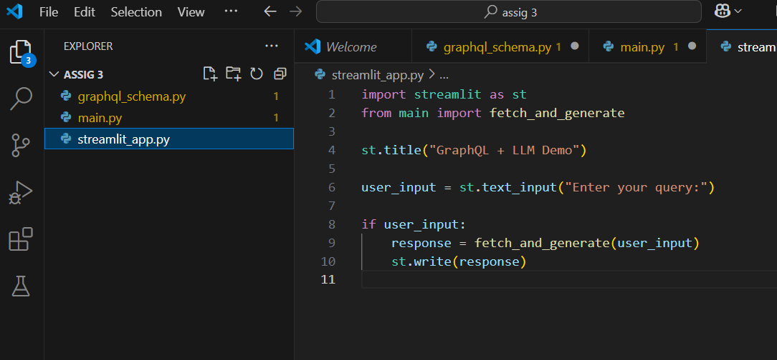

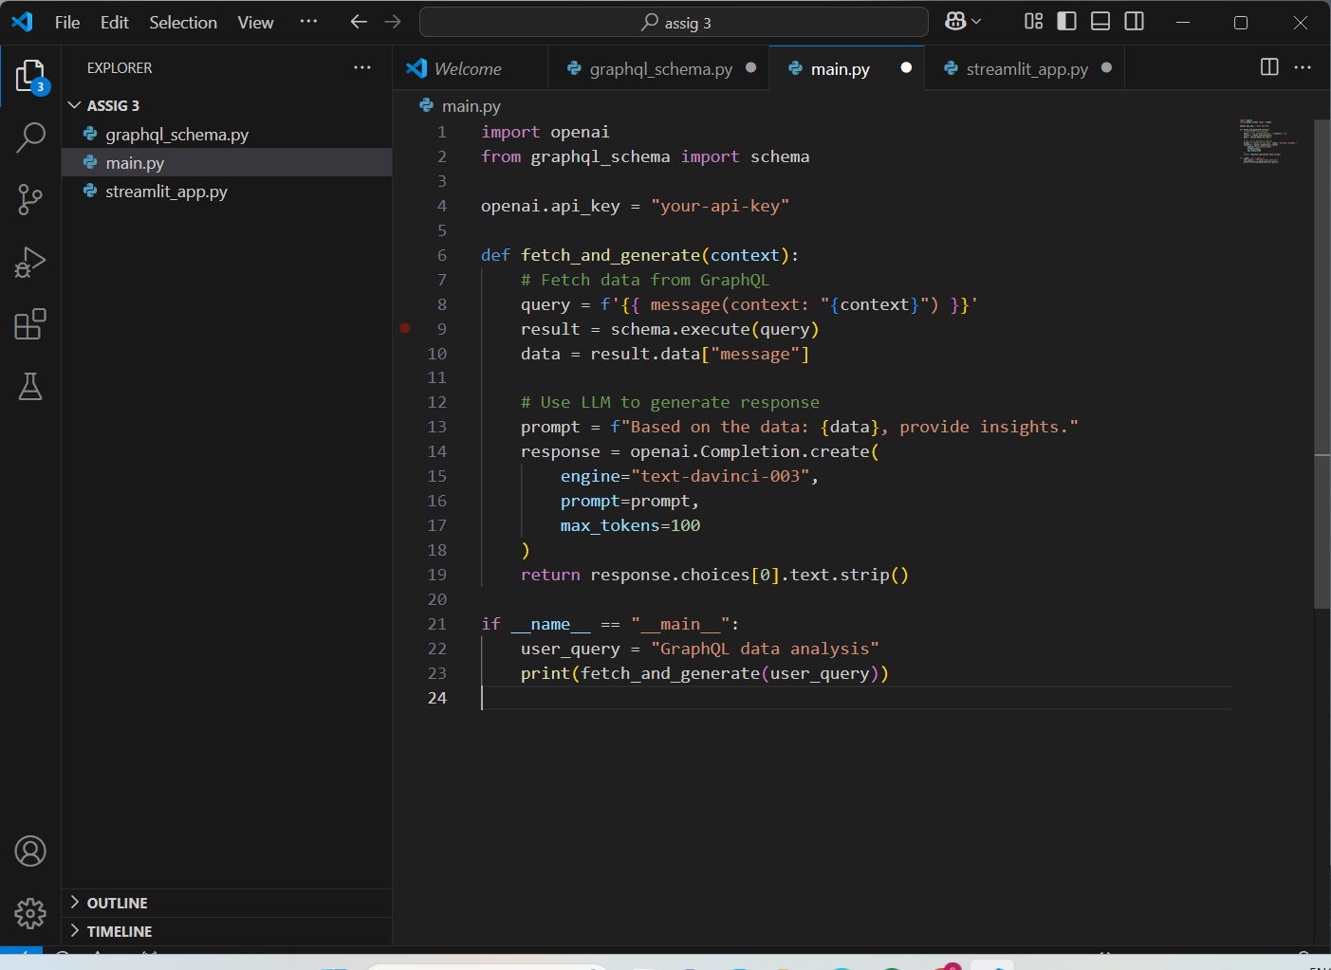

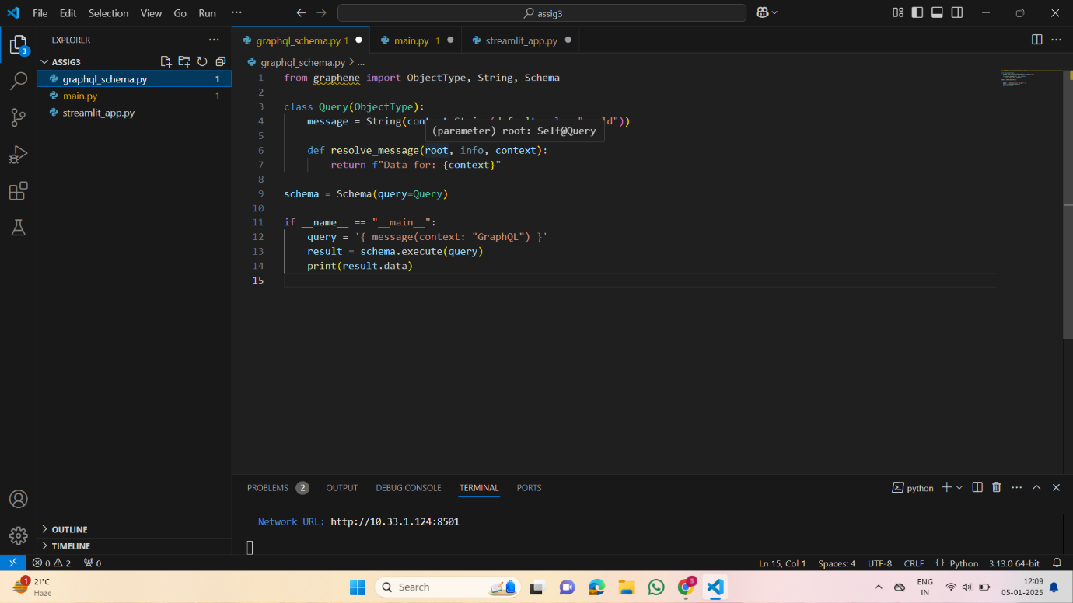

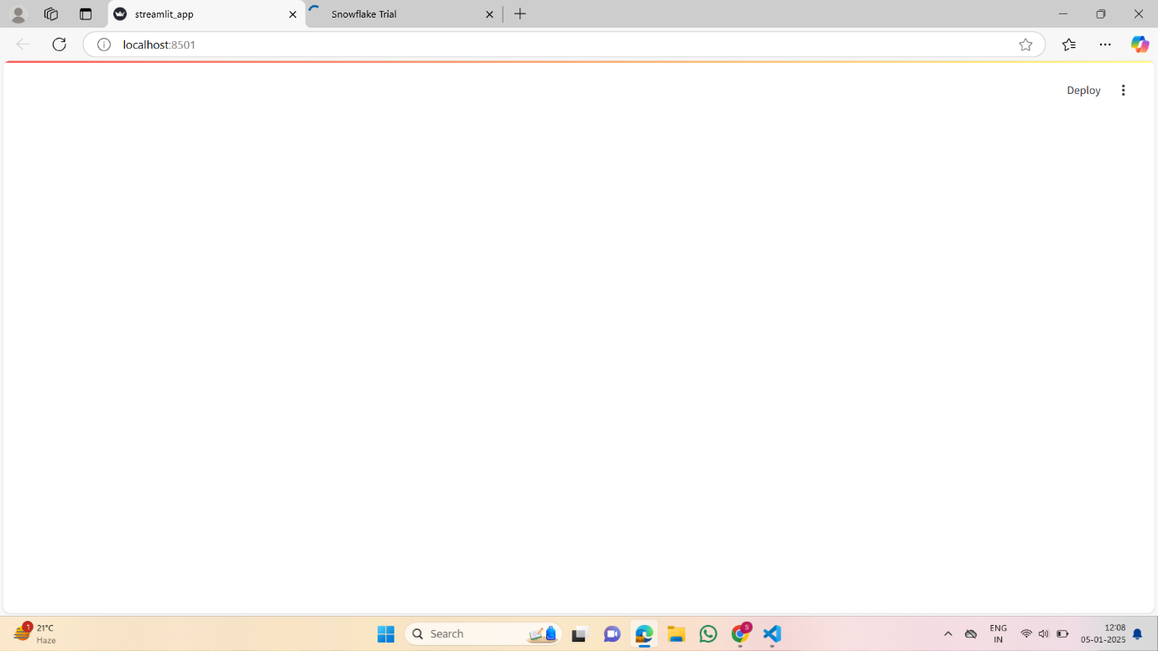

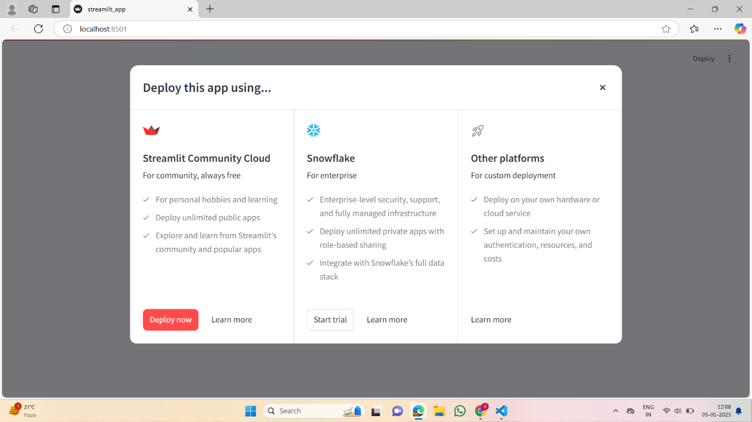

**4.STRIDE Threat Modeling and Application for E-commerce Platforms**

Overview of STRIDE

STRIDE, developed by Microsoft, is a systematic framework for identifying and categorizing potential threats in applications and systems. Each letter represents a category of threats:

1. **Spoofing**: Impersonating users or systems.
2. **Tampering**: Unauthorized modification of data.
3. **Repudiation**: Denial of performing an action without evidence to refute it.
4. **Information Disclosure**: Unauthorized access to sensitive data.
5. **Denial of Service (DoS)**: Disrupting service availability.
6. **Elevation of Privilege**: Unauthorized access to higher privilege levels.

Building a STRIDE Threat Model for an E-commerce Platform

Let’s consider applying STRIDE to platforms like Amazon, Flipkart, or BookMyShow:

1. Spoofing
   * Threat: Fake accounts or impersonation during user authentication.
   * Mitigation: Use strong authentication methods (e.g., Multi-Factor Authentication (MFA)).
2. Tampering
   * Threat: Altering product prices during transactions or modifying orders.
   * Mitigation: Implement HTTPS, digital signatures, and server-side validation.
3. Repudiation
   * Threat: Users denying purchases or activities.
   * Mitigation: Enable comprehensive logging using tools like AWS CloudTrail or Elasticsearch, ensuring logs are tamper-proof.
4. Information Disclosure
   * Threat: Leaks of customer data, such as through unsecured APIs or databases.
   * Mitigation: Encrypt data in transit (TLS) and at rest, and use role-based access control (RBAC).
5. Denial of Service (DoS)
   * Threat: Attackers flooding the platform with requests to disrupt services.
   * Mitigation: Use rate limiting, CDN services like Cloudflare, and DDoS protection tools like AWS Shield.
6. Elevation of Privilege
   * Threat: Exploitation of application flaws to gain administrative privileges.
   * Mitigation: Enforce the principle of least privilege and conduct regular penetration testing.

Key Steps in Threat Modeling

1. Decompose the System: Identify components, data flows, and trust boundaries.
2. Apply STRIDE: Analyze each component for potential threats.
3. Assess Risk: Evaluate likelihood and impact to prioritize mitigations.
4. Implement Controls: Develop measures to mitigate identified threats.
5. Review Regularly: Update the threat model as the system evolves.

Using STRIDE helps align security efforts with the design and operational aspects of an e-commerce platform, ensuring robust protection against emerging threats.

**5.HTTP Security Headers**

HTTP security headers are directives used by web servers to communicate security-related configurations to clients, primarily browsers. They play a key role in mitigating risks such as cross-site scripting (XSS), clickjacking, and protocol downgrade attacks. Below are some essential security headers:

1. **Strict-Transport-Security (HSTS)**
   * Ensures communication happens only over HTTPS, preventing protocol downgrade attacks.
   * Example:
   * Strict-Transport-Security: max-age=31536000; includeSubDomains; preload
2. **Content-Security-Policy (CSP)**
   * Prevents XSS, data injection attacks, and clickjacking by defining which resources are allowed to load.
   * Example:
   * Content-Security-Policy: default-src 'self'; img-src https://example.com
3. **X-Frame-Options**
   * Protects against clickjacking by preventing the site from being embedded in an iframe.
   * Options: DENY, SAMEORIGIN, or ALLOW-FROM.
   * Example:
   * X-Frame-Options: SAMEORIGIN
4. **X-Content-Type-Options**
   * Prevents MIME-type sniffing to avoid executing malicious files.
   * Example:
   * X-Content-Type-Options: nosniff
5. **Referrer-Policy**
   * Controls how much information about the referrer is sent in requests.
   * Example:
   * Referrer-Policy: no-referrer-when-downgrade
6. **Permissions-Policy**
   * Controls access to APIs and browser features like camera, microphone, or geolocation.
   * Example:
   * Permissions-Policy: geolocation=(self)
7. **Expect-CT (Certificate Transparency)**
   * Ensures the browser enforces certificate transparency logs, preventing misissued certificates.
   * Example:
   * Expect-CT: max-age=86400, enforce
8. **Cross-Origin Resource Sharing (CORS)**
   * Controls how resources on the server are shared across domains.
   * Example:
   * Access-Control-Allow-Origin: https://example.com

**6.HTTP Status Codes**

HTTP status codes indicate the result of the client’s request to the server. They are grouped into five categories:

**100 Informational**

* **100 Continue**: Initial part of a request has been received and the client should continue.
* **101 Switching Protocols**: Server is switching protocols as requested by the client.

**200 Success**

* **200 OK**: Request succeeded.
* **201 Created**: Resource has been successfully created.
* **204 No Content**: Successful request but no content to return.

**300 Redirection**

* **301 Moved Permanently**: Resource has been permanently moved to a new URL.
* **302 Found**: Temporary redirection to another URL.
* **304 Not Modified**: Cached version of the resource is still valid.

**400 Client Errors**

* **400 Bad Request**: Invalid request syntax or parameters.
* **401 Unauthorized**: Authentication required.
* **403 Forbidden**: Client does not have permission to access the resource.
* **404 Not Found**: Resource could not be found.
* **429 Too Many Requests**: Client has sent too many requests in a short time.

**500 Server Errors**

* **500 Internal Server Error**: General server error.
* **502 Bad Gateway**: Invalid response from an upstream server.
* **503 Service Unavailable**: Server is temporarily unavailable (e.g., maintenance).
* **504 Gateway Timeout**: Upstream server did not respond in time.

Understanding these headers and codes is critical for building secure, robust web applications. Would you like a deeper dive into any of these?